Academic Path

At first, I chose architecture simply because I loved drawing and was good at it. However, in high school, a physics essay completely shifted my perspective on what I wanted my career to be. Living in Indonesia, a country along the Ring of Fire that is constantly prone to earthquakes, I experienced a major earthquake late one night. While my school suffered heavy destruction the next day with collapsed walls, my family’s house barely faced any damage at all; nothing happened except a helmet falling off a cupboard.
Our house was built as a traditional stilt house, rooted in the heritage of Kampung Naga, an old village near my hometown where my grandfather’s lineage descends from. Intrigued by how our house survived, I conducted high school research on how the flexible structure of traditional stilt houses naturally absorbs seismic shocks and minimizes destruction. That experience transformed architecture from a simple drawing hobby into a meaningful purpose: exploring structures that keep people safe.
Because of that deep passion, my initial plan was to pursue a 5-year Bachelor of Architecture at Zijing College. However, as someone whose family cannot support overseas studies, I faced a tough dilemma. The government scholarship I received strictly covers programs of four years or less. I had to choose between gambling a fifth year of university without the means to pay for it, or taking a "safe" 4-year option in standard engineering. It wasn't that one major was better than the other, but simply a choice between passion and financial safety.
Everything changed when I arrived at Zijing College and experienced its interdisciplinary STEAM learning framework, STEM with an "A" for Art, Architecture, and AI. In our first year, we focus on core foundations like calculus and linear algebra before choosing a major track. The college uses the analogy of growing our roots and trunk first before expanding into branches. For someone facing my exact dilemma, that "A" in STEM lit up a spark of hope.
Zijing offered a 4-year degree pathway in Design Science, allowing me to specialize in majors like Urban Planning and Landscape Architecture while staying fully funded by my scholarship. This completely reshaped how I view my future. On a recent flight back to Jakarta, I observed the city from above and noticed its chaotic layout, houses facing every random direction, mismatched spatial organization, and the stark economic disparities tied directly to how the city grew.
Now, my path embraces two deeply meaningful directions: exploring earthquake-resilient structures inspired by Kampung Naga, and addressing real-world spatial equity through Urban Planning. Zijing didn't force me to abandon my passion; it gave me the foundation and freedom to actively shape it.

Interest / Hobby

With this re-exploration of art, I started spending a lot of time creating again. While some of it includes coursework like pottery and a 3D Virtual Garden, my more personal exploration involves drawing portraits for my friends' birthdays.
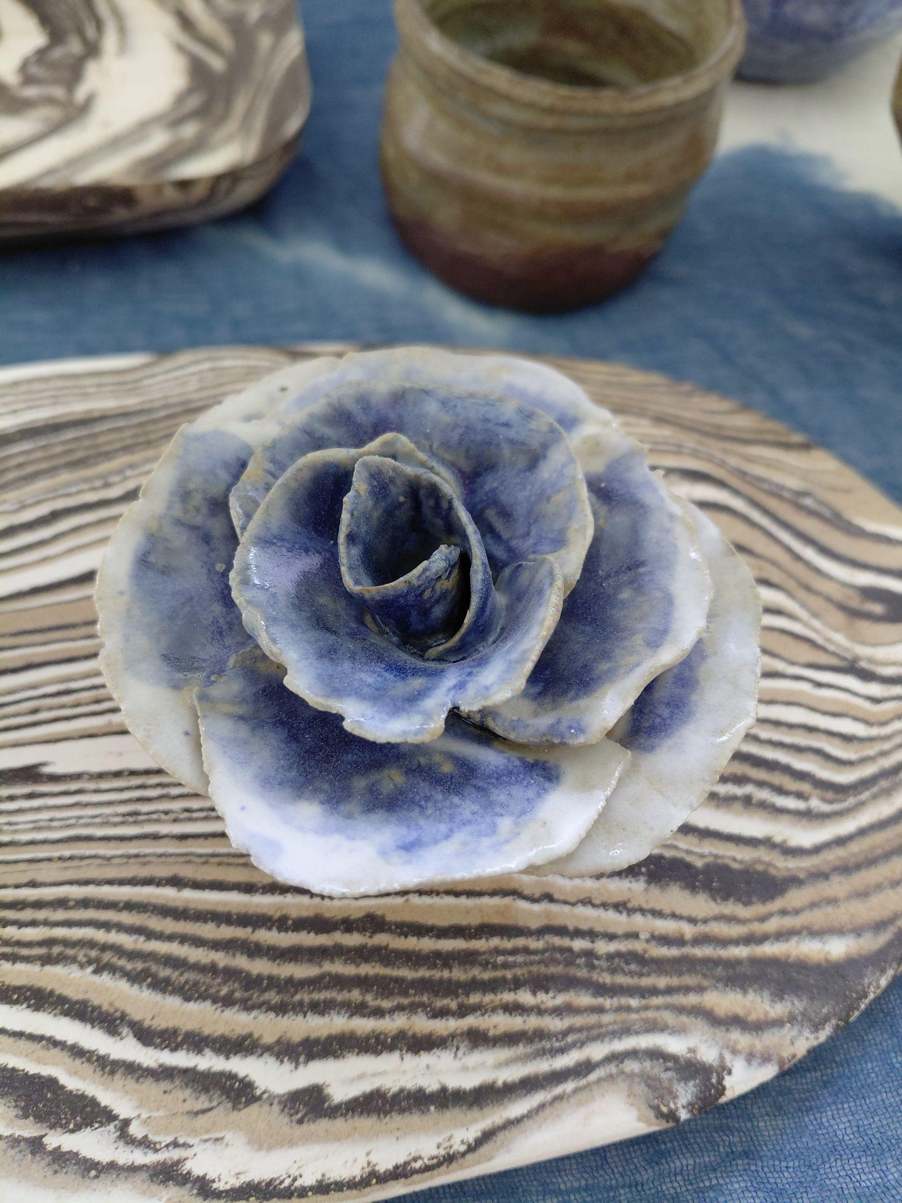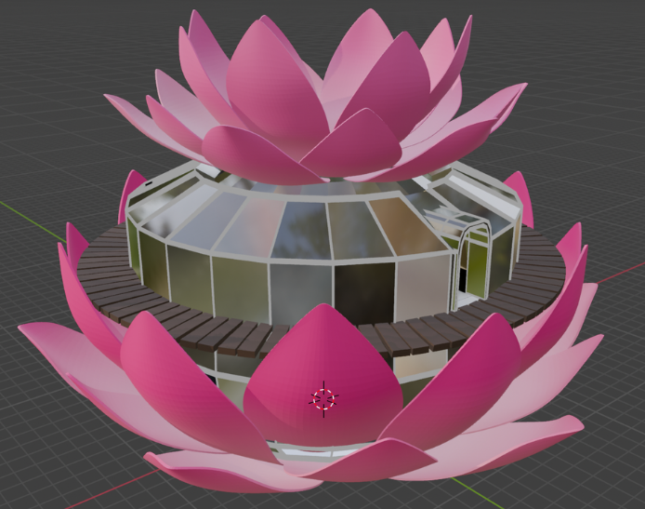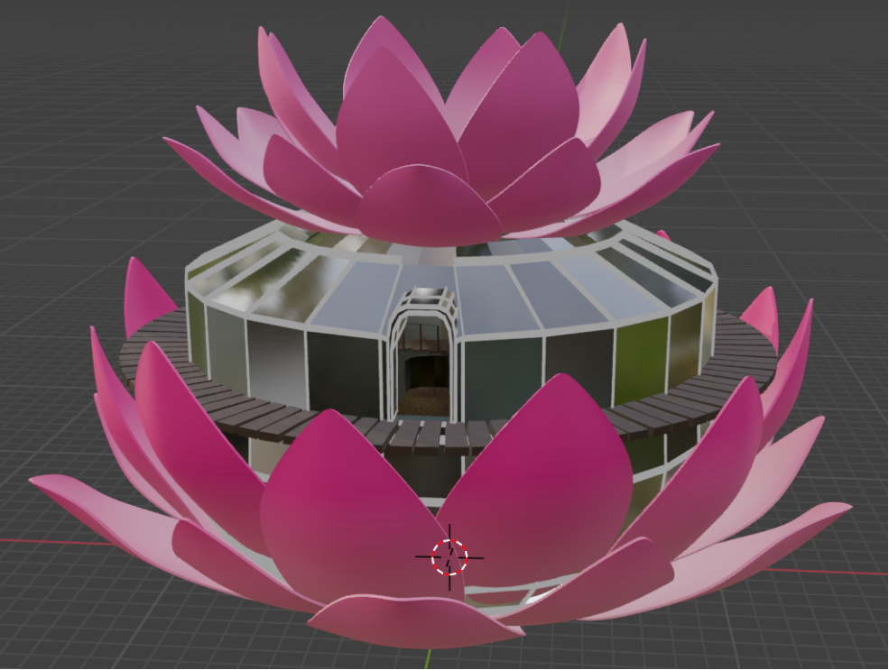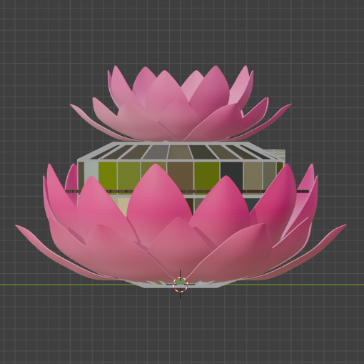

Ever since I was little, my art mainly consisted of 2D drawing and animation. However, as I grew older around junior high school, I developed a strong interest in realistic art. Over time, drawing portraits became a medium for me to express my feelings toward the people around me, my love language, giving them a glimpse of how I perceive them. That's why reigniting my passion mostly involved drawing portraits of my friends, expressing my appreciation for them while experimenting with new media in the process.

Some of the portraits: I have one portrait on progress right now
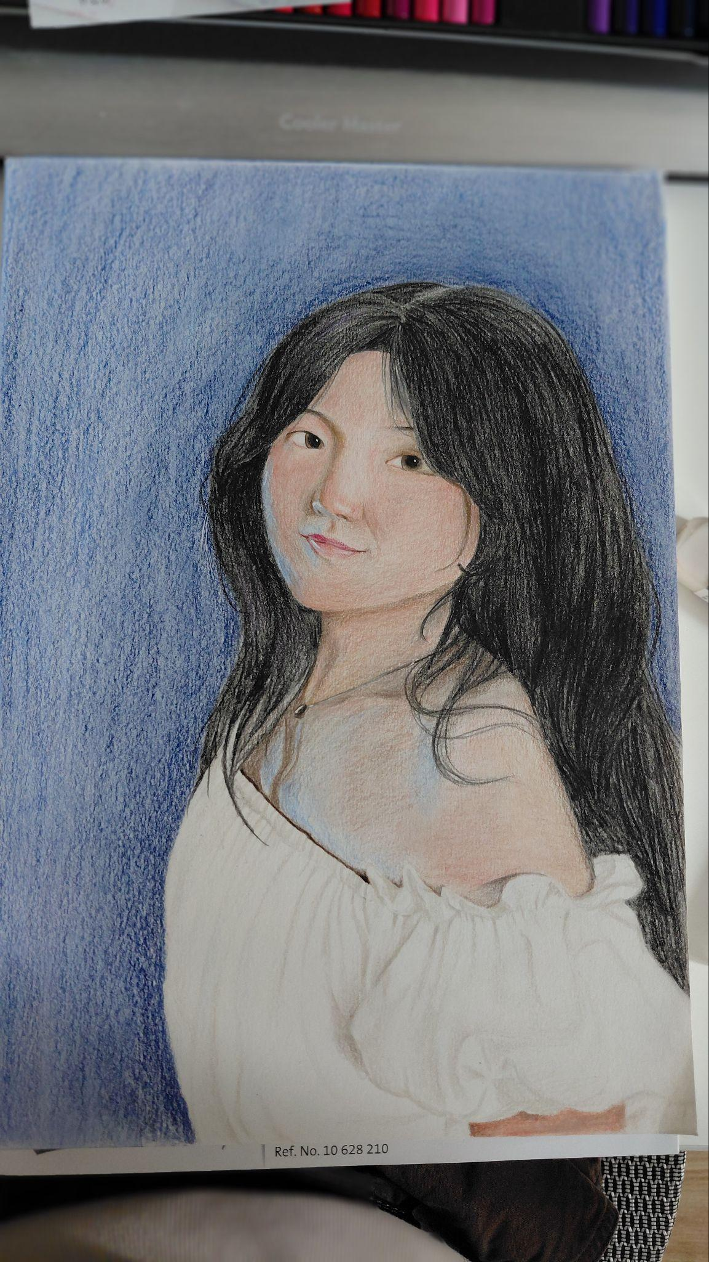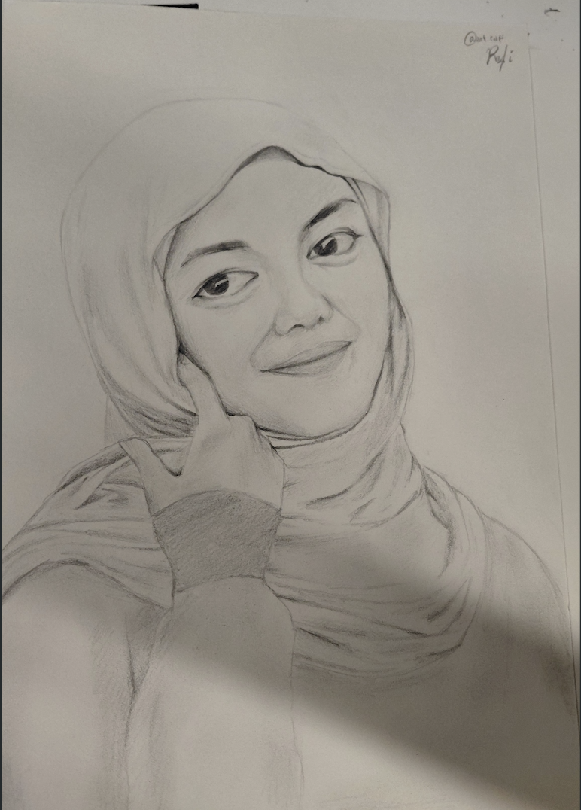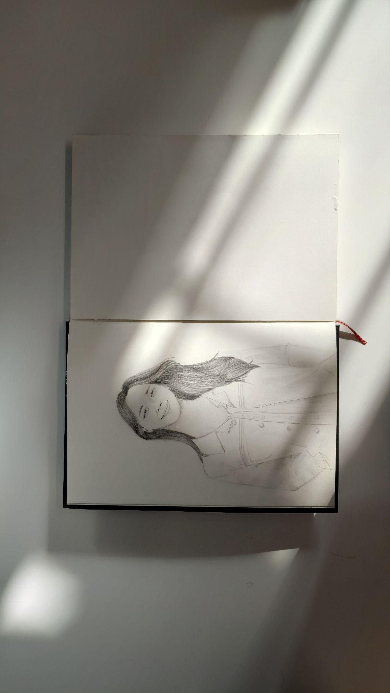
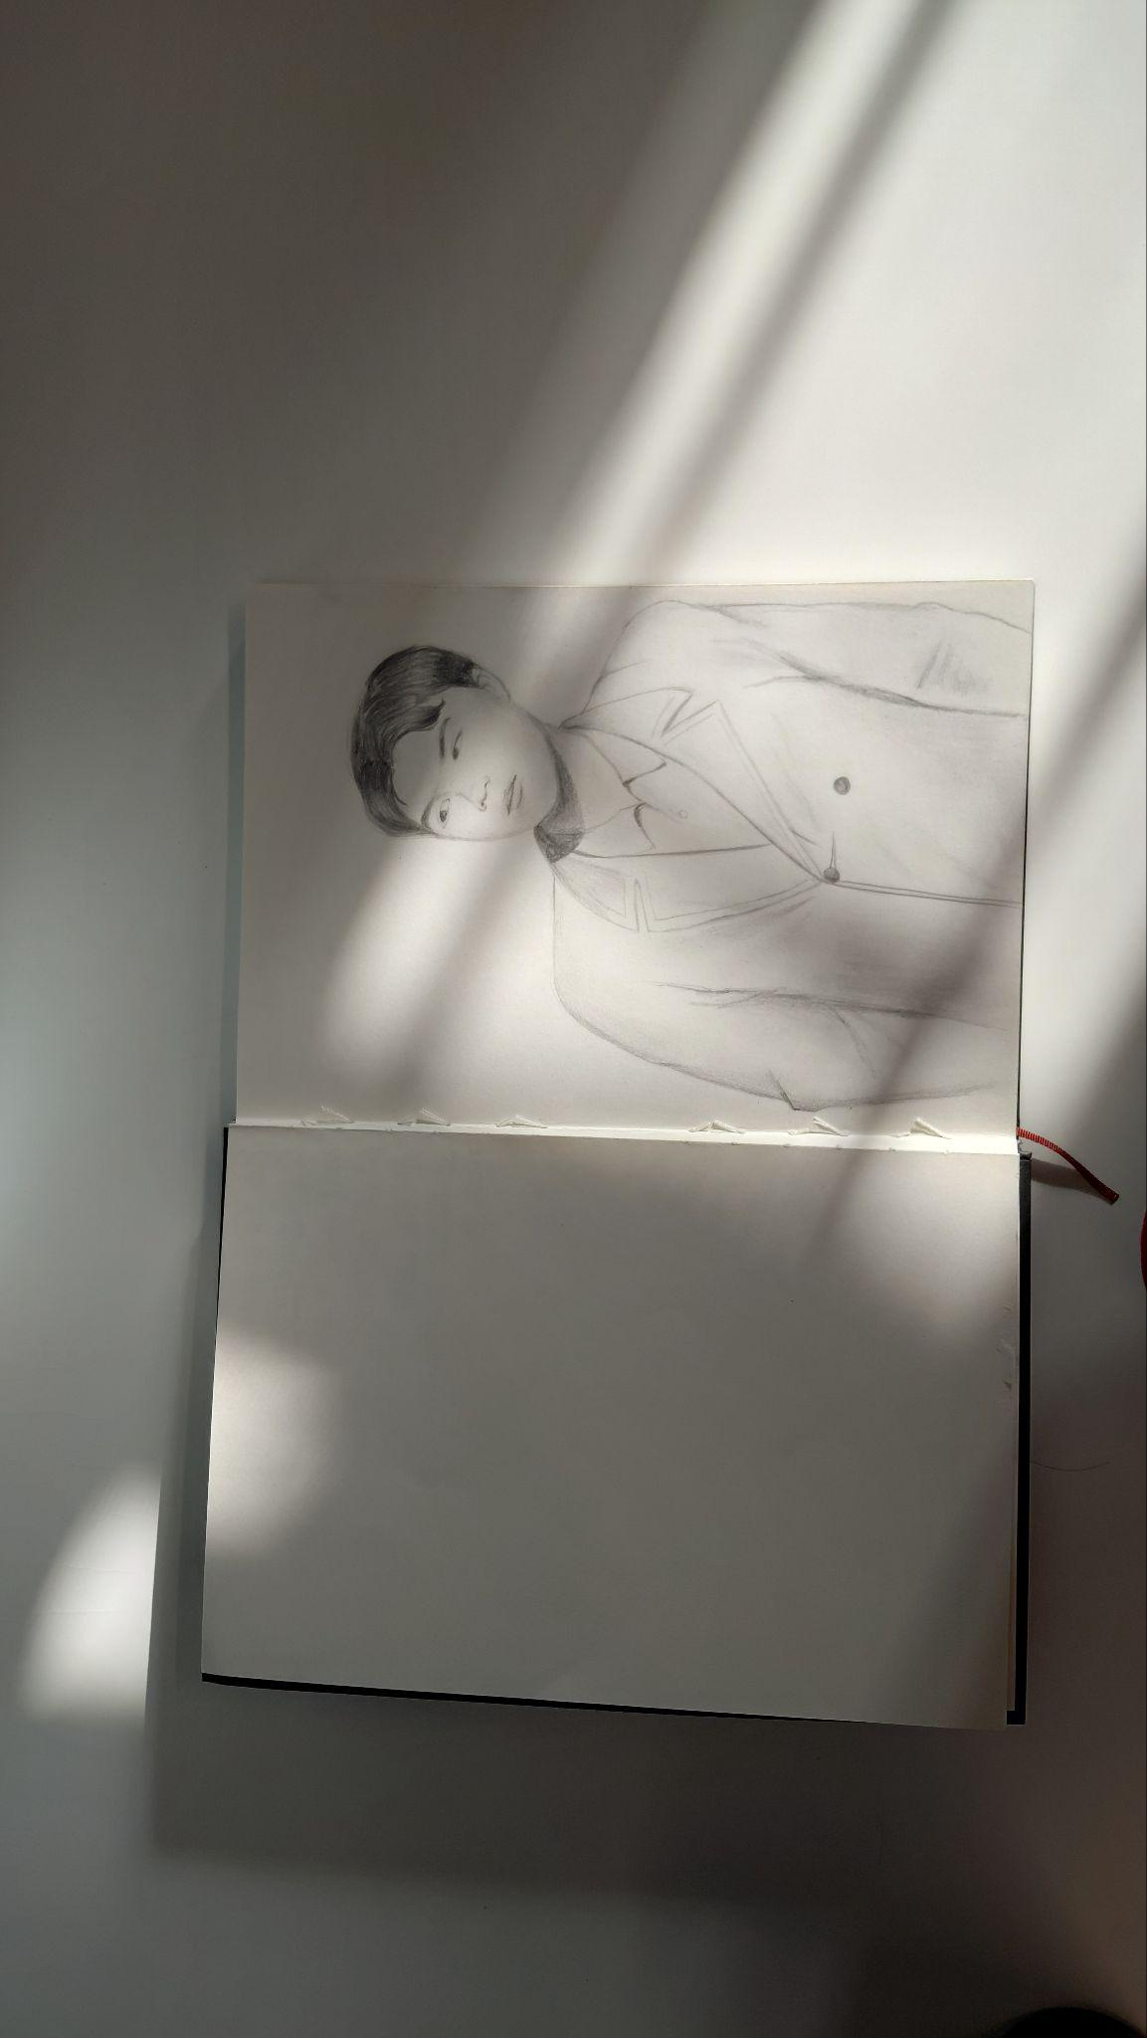
While drawing was a passion I had lost for a while, my appreciation for beauty was always there, especially through my deep interest in K-pop. K-pop is a visually focused industry, which is why idols became one of my main inspirations and drawing subjects around the time I started practicing portraits. As my interest in their visuals grew, my passion for music, dancing, and being on stage grew right alongside it.

I have always loved singing, but in high school, I never had the chance to perform musically, so I shifted my focus toward becoming an MC instead. I frequently hosted events in high school, largely rooted in my early background reciting poetry. However, at Tsinghua, I finally got the chance to perform live at the Tsinghua Indonesian Students Association welcoming party and eventually became part of the Zijing Band.

The same goes for dancing; I never really had the chance to perform in high school, but I found so many opportunities at Tsinghua. From performing traditional Indonesian dance at the Tsinghua Gala Night in December 2025 to dancing like a K-pop idol in the Ma Cup competition and performing at Zijing College's 1st Student Festival in 2026, these moments are things I genuinely cherish. It reminds me of the advice not to turn every hobby into a career. While drawing might connect to my future profession, singing and dancing remain my safe space, the place I turn to when I need a break, and I am so grateful to have that here at Tsinghua.

Conclusion

Looking back, coming to Tsinghua gave me the exact space I needed to connect my passion with a real career path. Through Zijing College, I didn't have to give up art to fit my 4-year government scholarship. Instead, it helped me turn my love for drawing into a meaningful purpose in Urban Planning, whether that's exploring earthquake-safe stilt houses inspired by my grandfather's heritage in Kampung Naga, or wanting to address messy city planning and spatial inequality in Jakarta.
At the same time, Tsinghua gave me a true safe space for my hobbies. Away from studio deadlines and class pressure, I found so many opportunities to perform on stage, singing with the Zijing Band, hosting events as an MC, performing traditional Indonesian dance at Gala Night, and dancing K-pop routines at the Student Festival. Singing and dancing remain the safe space I run to when I'm tired, giving me a place to reset and just enjoy myself.
None of this would be possible without the community here at Zijing College. The college has really felt like a friend to me, surrounding me with peers from around the world who share their own struggles, along with professors and advisors who helped me make tough decisions along the way. Tsinghua gave me both a clear path to build my future career and a warm, supportive community where I can truly be myself.

